**

**Remove all method -**

**What happens when custom class has duplicates-**

Still, we get all values because every object of custom class is treated differently. Every object is stored in different heap memory and object references are stored in different stack memory.

**Size method-**

**Note for comparable class which is created -**

If we sort based on something which is not having **value or is null,** then we get exception again. So **comparable** to be used on that variable which will not be **zero or null.**

**Hash set to link hash set–**

**Hash set to tree set-**

single null value in tree set also causes null pointer exception-

commented **line 24.**

Even if the other collection has null tree set will not allow –

Commented **line 23.**

No null allowed in other collection also-

Commented **line 17,** even single null not allowed-

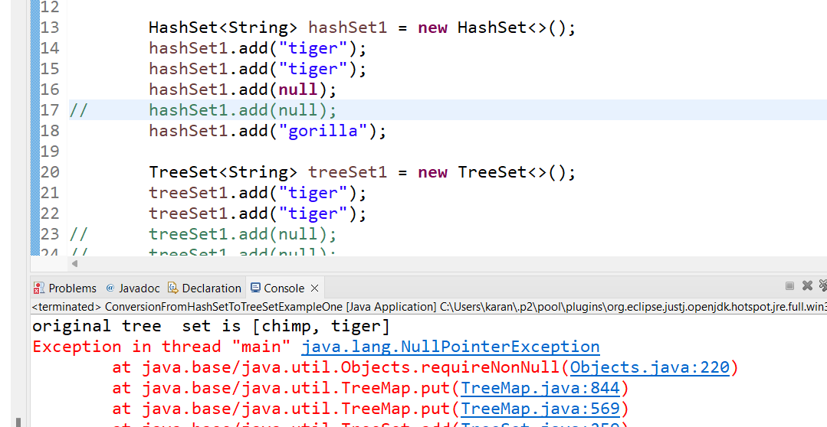

Remove all nulls from all collections and then **add** and it works-

Final code-

Final code-

**Linked hash set to hash set-**

**Tree set to hash set-**

Even one null not allowed in tree set-

Commented **line 18.**

Final code-

**Link hash set to tree set-**



**Tree set to link hash set-**



